Assigned User Information
Name _________________________________ # of grids dropped off ____________________
LDAP username _________________________ # of grid boxes dropped off ________________
PI & Institute ____________________________ Gridbox description ______________________
Today’s date ____________________________ Krios # ________________________________
Krios session date(s) _____________________

Krios grid drop off checklist

- I understand that all grids will be clipped and loaded following the SEMC numbering system (see image below)
Yes 🡪 Grid Priority: 1. _____________

2. _____________
3. _____________
4. _____________
- Are we clipping your grids?
Yes

No – I verify that my clip rings were purchased from TFS and have not been reused or were damaged during clipping protocol. All users are responsible for proper labeling of their grid boxes.

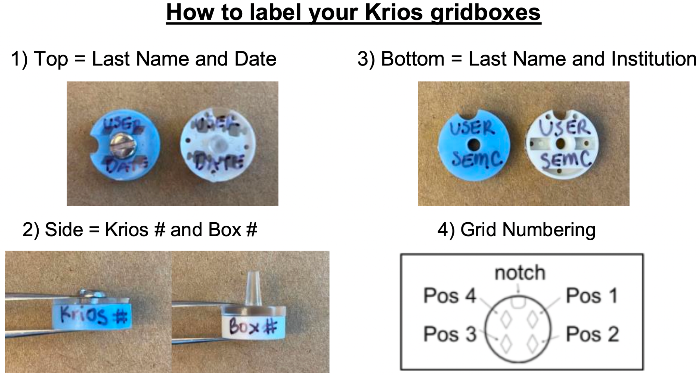

I understand that only 4 grids are guaranteed in a 2 day session.

I understand that all grids saved from the session will be stored for 2 weeks only.

_________________________________________________________________________________________________
Print name and signature (USER) Date
_________________________________________________________________________________________________
Print name and signature (STAFF) Date
------------------------------------------------------------------------------------------------------------------------------------------------------------------
Staff Use Only
# of grids clipped __________ # of unclipped grids __________ clipped by ___________________ date _____________

Page 1 of 2

Krios pre-session questionnaire
- What type of experiment are you doing? Circle one:

Single Particle Analysis (SPA) Tomography (Please email emg@nysbc.org ahead of your session to
Other: __________________ confirm your data collection goals and parameters.)

- What project are you collecting under? If you have not registered the project yet, you can do so here.
(https://deon.nysbc.org/project/submit/)

Project name: _______________________________________________________________________________

- Dose rate and frame rate (circle one):

K3 = 30 e⁻/pixel/sec dose rate, 50 ms/frame
Other, please specify: ________________________________________________________________________

- Pixel size (circle one):

~1.1 Å/pixel (standard)
Other, please specify: ________________________________________________________________________

- K3 camera acquisition mode (circle one):

Counting (standard) Super-resolution (processing will lag behind collection)

- What is the hole size? ____ µm. If possible, would you like multiple targets per hole? Circle one: Yes No

- Are you sharing your session with another user or member institution? Circle one: Yes No

- Were these grids screened prior to the session? Circle one: Yes No

- I would like to have cryoSPARC Live running concurrently with the session (not guaranteed). Circle one: Yes No
*Only available on-site
Particle Diameter 🡪 Min: ________ (Å) Max:________ (Å)

- Have you registered a Globus account for data transfer? Click here (http://semc.nysbc.org/documentation) for more information.
Yes No (ask emg staff to assist in making one during your session)
Page 2 of 2

